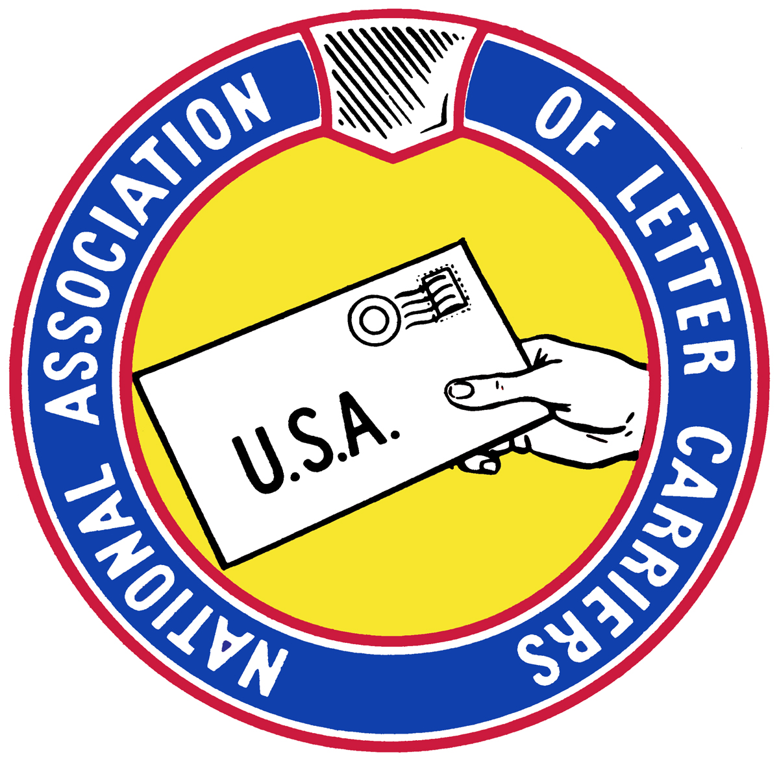
Press release
National Association of Letter Carriers
100 Indiana Avenue NW, Washington DC 20001
Phone: 202.393.4695 • www.nalc.org

FOR IMMEDIATE RELEASE
Contacts: Sept 19, 2018
Christina Vela Davidson 202-662-2489
Donna Peremes 202-662-2851

Letter Carriers Recognized as Heroes of the Year

WASHINGTON DC, Sept. 19, 2018 – Letter carriers who rescued people from raging house fires, saved numerous Houston-area residents from Hurricane Harvey’s raging flood waters and cornered a burglar who had terrified a young girl, are among those to be honored Sept. 26.

Jason Moss of Tampa, FL, and John Sylvain, an Army veteran from Fort Lauderdale, FL, who each risked their lives battling heat and smoke to save two residents apiece trapped by fires in their homes in separate incidents that were virtually mirror images, are the National Heroes of the Year – the first time judges have selected two winners. Ebony Nobles of Houston, an Afghan war veteran who in just her first few weeks delivering mail coordinated rescues of residents, rescued others herself as an Army reservist, led a clothing drive and delivered food to shelters, is the National Humanitarian of the Year.

Several other carriers also are being recognized as heroes. They represent thousands of letter carriers who not only deliver the nation’s mail six or even seven days a week, but often assist in situations involving accidents, fires, crimes or health crises.

Peter Monteleone of Westchester County, NY, a Navy Cold War veteran who comforted the young girl while forcing the burglar to stay put until police arrived, is the Eastern Region Hero of the Year. Brandon Franklin of Waterford, MI, who ran to reach a runaway Jeep whose driver had fallen unconscious and then in acrobatic fashion dove headfirst through the window to navigate the vehicle to safety as it neared a school zone, is Central Region Hero of the Year. Antonio Colon of Chino, CA, bravely responded to a 90-year-old woman’s cries that she was being assaulted; he is the Western Hero.

Naseem Elias of Sterling Heights, MI, who speaks six languages and whose fluent Arabic helped save a resident’s baby, will be honored with the Special Carrier Alert award. And three other Detroit-area active and retired letter carriers – Dennis Denham, Steven Futach and Joseph Pomante – will receive the Unit Citation award for coming to the aid of an elderly resident experiencing a medical crisis.

The National Association of Letter Carriers Heroes of the Year will be honored by NALC President Fredric Rolando at a special luncheon at noon on Wednesday, Sept. 26, at the Hyatt Regency Hotel, 400 New Jersey Ave. NW, Washington D.C. Go to nalc.org/heroes for further information on the Heroes, including text and pictures.

******
NALC represents letter carriers across the country. Its 280,000 members make it the largest of the four unions representing employees of the United States Postal Service. Founded by Civil War veterans in 1889, NALC is among the country’s oldest labor unions.

