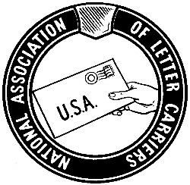
ADVANCED FORMAL A and BEYOND TRAINING PROGRAM
******* Application Form ********

The following applicant from NALC Branch # would like to attend the “Advanced Formal A and Beyond” training program to be held at the Maritime Institute in Linthicum Heights, MD in 2019 if possible.
Name: Cell Phone:

Address:

City: State: Zip:

- mail address:
Criteria Requirements:

Applicants must have some experience presenting grievances at the Formal Step A level of the grievance procedure.
  - Applicants must be able to bring a laptop computer that is not an Apple product.

Participants will be selected on a first-come, first-served basis. Once selected, participants will be notified that they have been selected and they will be provided further details and payment deadline information.

The cost of attending this training will be the branch/participant’s responsibility.

The NALC has secured a rate of $240.44 (single occupancy) or $359.97 (double occupancy), per day plus tax, based on a five-night stay at the Maritime Institute. This includes a room, all meals, and refreshments during breaks. The total cost of this training is $1,202.20 (single) or $1,799.85 (double).

Please do not make travel arrangements until you are officially notified that you have been selected to attend the “Advanced Formal A and Beyond” training program.
(Please select a preference): □ Sept 29-Oct 4, 2019 □ November 3-8, 2019
If you are not selected for, or are unable to attend the Sept 28-Oct 4 Class or November 2-8 class in 2019, do you wish to be considered for future classes?
[ ] YES [ ] NO [ ] I cannot attend this year, but I would like to attend in the future.

I certify that I meet the above-referenced criteria needed to attend this training program.

Applicant’s Signature

Mail completed form to: NALC Vice President Lew Drass
100 Indiana Ave. NW Washington, DC 20001-2144

